Synaptic Caguamas
Subsculpture 4
By Rafael Lozano-Hemmer

General Important information
Description
Operation
Cleaning
Placement Suggestions
Software

Detailed Technical information
Components of the piece
Troubleshooting

General Important information

Synaptic Caguamas, Subsculpture 4 (2004), glass bottles on motorized wooden table, PC running algorithms that simulate neuronal activity, 87x 210 x 180 cm. Edition of 3 +1AP
By Rafael Lozano-Hemmer

Description

Synaptic Caguamas is a kinetic sculpture consisting of a motorized Mexican “cantina” bar table with 30 “Caguama”-sized beer bottles (1-litre each). The bottles spin on the table with patterns generated by cellular automata algorithms that simulate the neuronal connections in the brain. Every few minutes the bottles are reset automatically and seeded with new initial conditions for the algorithm, so that the movement patterns are never repeated. This kinetic sculpture is a primitive and absurd attempt to make tangible the mathematics of recollection and thought.

Assembly

The piece should come in a wooden crate containing the following elements:

- 1 tabletop with 30 motors, 6 power bars, 30 small Ethernet cables and 30 power supplies and cables, all connected and secured.
- 3 spare motors
- 5 table legs (3 without holes, 2 with holes for passing cables)
- 16 screws to assemble the legs
- 30 numbered bottles with glued-on collars
- 5 extra bottles with glued-on collars
- 5 extra bottles without collars
- 1 USB to RS-485 converter (a small green circuit board)
- 1 laptop computer with power supply
- 1 long Ethernet cable

As the tabletop is very heavy, several people will be required to assemble the legs onto it. One way to do it is to have 4 or more strong persons hold up the tabletop, while 4 more each screw in a leg, or to use padded crates for the top to rest on. Another method is to lay the top upside down on the floor, mount the legs and flip the entire table, but it is important to avoid any lateral pressure on the legs. Note that each leg goes in a particular corner, indicated by the letters written under the table. Use the long bolts and nuts provided.

5 legs are included with the table, two of which have cables running through them. The 3 legs without cable holes are always used, and the 4th leg to use depends on how the cables will run from the table. If you have a trap on the floor under the table where you can run the power and Ethernet cable, you may want to use the leg that brings the cabling under the table, towards the centre of the piece. If however the cables are going to run on the floor towards a nearby wall, you’ll want to use the leg that lets the cables out of the leg towards the outside of the table. After securing the cabled leg, plug the first power bar into the leg’s power outlet, and plug the leg’s Ethernet cable into the free Ethernet slot of the closest motor; the one on the corner.

Once the legs have been assembled and the table is upright, the bottles should be positioned. Each bottle has a collar that has been numbered to fit with a corresponding shaft on the table. Most bottles can be interchangeable, but these numbered positions have been identified as being ideal to make sure that each bottle is nicely parallel to the table. The tops of the shaft are also numbered; here is a small diagram for clarity:

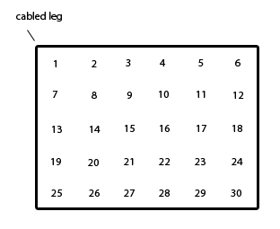

In addition, assuming that the shafts have stayed in place during shipping, the bottles should all be installed with the same orientation, all pointing left on the diagram above, with the collar towards the cabled leg. To ensure a snug fit, the shafts of the motors have been fitted with small pieces of plastic. Simply line up the hex pattern on the bottle collar with the shaft protruding from the table and with a firm grip, rock the bottle back and forth lightly while pushing down until the collars are fully interlocked. Handle the bottles very carefully.

Once the bottles have been assembled, plug the male end of the power cable coming out of the leg to a normal wall outlet. The table can run on either 110V or 220V power, as all the elements it contains are auto-switching. Ideally, an independent circuit should be used for this since the motors are a highly inductive load and may interfere with other electronics. One circuit can easily power the whole table, as the current draw is around a tenth of an amp. Finally, plug the Ethernet cable to the small USB to RS-485 converter, which in turn should be connected to the MacBook laptop via USB.

Operation

To turn ON Synaptic Caguamas, turn on the laptop. Once Windows has loaded, the Synaptic Caguamas software will start automatically, and a calibration routine will start. Let the computer work through this process, and after a few minutes the piece will start functioning as normal.

If this is the first time you turn on the table, everything should run as intended as long as the preceding instructions were followed. Still, it may be a good idea to verify that the bottle movements being displayed on the computer screen are indeed coherent with the movement of the bottles on the table.

While you should not need to navigate the software, we have included a detailed description of the options it offers. Refer to Annex A for details.

To turn OFF Synaptic Caguamas, first press the power button on the laptop to trigger the Windows boot down sequence. Then turn off the power to the table, either by unplugging it, flipping the switch on the power bar, or turning off the appropriate circuit breaker in the building.

Cleaning

The piece will get dusty over time, and it is a good idea to clean it regularly. To do so, first turn it OFF by pressing the power button on the laptop. When the bottles stop turning, you can wipe the table with a soft cloth and some water, or use a cleaning agent that is not too strong so as to preserve the paint. It should not be necessary to remove the bottles, but if you choose to do so, handle them with care.

Software

When the computer boots up, the Synaptic Caguamas software starts automatically and sends the motors into an initialization sequence. Once the motors have been initialized automatically, the piece starts running as normal.

Below is a screen shot of the main window.

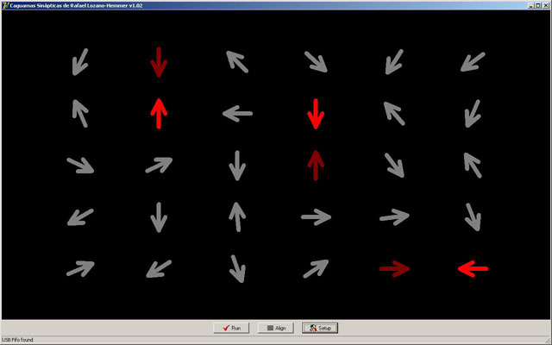

At the very bottom left of the screen, a status bar shows the status of the external USB circuit board. It should say, “USB Fifo found”. If it says “USB device not found” or “Can’t connect on COM port”, it could be that the USB cable to the circuit board is unplugged.

Three buttons are displayed:

Run
This button is automatically activated when the piece starts and launches the normal operating mode of the piece. The only time the software exits this mode is when the user goes into the setup screen. Upon exiting the setup screen, one may press the "Run" button to send the piece back into its normal operating mode.

Align
This button momentarily interrupts the automatic operation of the piece and forces all the bottles to line up perfectly. It is used to verify that the bottles are oriented correctly. It

Setup
This button opens the setup window through which most of the technical parameters for the piece are accessed. The setup window is shown below.

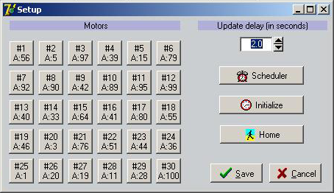

Starting on the right side, we find the following options:

Update delay
This is an internal timing parameter used for the RS-485 communication and should be left at the default value of 2.

Scheduler
This button brings up a window that allows the user to automate the operation of the piece throughout the weeks by choosing the on-screen instructions. The scheduler window is shown below.

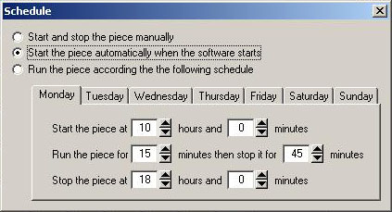

By default the software is only set to run automatically when the computer turns on. As giving the piece some time to rest will lengthen its lifespan, it may be wise to give some thought to when it doesn't need to be active. The scheduler is also useful for a museum setting, where weekly opening hours dictate the appropriate running times for the piece.

Initialize
This button is not normally used as the initialization sequence happens automatically at startup. It is kept here as a shortcut for performing technical diagnostics.

Home
Likewise, this button forces all motors to their initial position and should not be needed outside of technical diagnostic procedures.

Save and Cancel
Use one of these buttons to exit the setup screen, choosing "Save" if you'd like to save the changes you may have made, or "Cancel" if you'd like those changes to be forgotten.

Motors
On the left side of the setup window, there are 30 buttons corresponding to each one of the 30 motors. The button at the top left corresponds to the corner of the table where the cabled leg is. If you are going to perform a one-by-one calibration of the bottles, it is recommended or convenience that you setup your motors so that button #1 corresponds to the motor in the upper left hand corner of the table, relative from your point of view from the computer screen. This will make is easier to identify and select a particular motor later on.

To setup or control an individual motor, press its corresponding button.

Beneath the bottle # label, there’s another label in the form "A: XX" where XX is any number from 1 to 255. The letter refers to the link the bottle is on. The USB board may have two RJ-45 (Ethernet) connectors, to control two RS-485 lines at once. For this piece, it’s recommended to put all 30 motors on the same link, #1 or "A". This link is the RJ-45 connector closest to the USB connector. The "XX" portion of the label, the second number (1-255) is the address of the motor. In order to individually address each motor, the system needs to know each motor’s address. Each motor has a circuit board on it that monitors the RS-485 line for data with its address attached to it. It will only respond to data with its matching address.

To set this address and other parameters of the motor, press the corresponding motor button. This will open up the following screen.

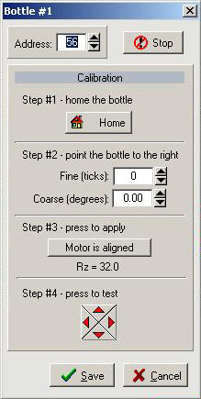

The first field in the Bottle window is the Address field. Each motor has a little sticker on its circuit board with a number. This is the address of the motor, which must be entered in the corresponding address field.

The Stop button, as it indicates, stops all current activity on the motor.

The Calibration section of the Bottle window takes the user through the 4 steps of the calibration process that ensures the correct orientation of the bottle.

Step 1 - Home the bottle. Pressing this button brings the motor to its position "0".

Step 2 - Point the bottle to the right. By using the ticks or the degrees, make the bottle turn until it points to the right, in perfect alignment with the rest of the table.

Step 3 - Apply. By pressing this button, you are confirming the orientation of the bottle.

Step 4 - Test. Use the 4 arrows to double-check that the bottle responds correctly to directions.

Save the changes or Cancel.
Troubleshooting

A) None of the motors are responding.

- Make sure that the computer is on and connected, and that the motors are receiving power.

- Check the caption at the bottom of the main screen. If the device isn’t found check the cables. If the cables are ok, the driver for the USB device might not be loaded. The driver is on the CD in a folder called “D2XX”. To install the driver, first quit the program. Then right click on the “My computer” icon on the desktop, and select properties from the menu that opens up. Select the hardware tab then press the “Device Manager” button. There should be a device under the ports section with a surprise mark beside it. Right click on it, select “Update driver”, and tell windows not to connect to Windows Update. Press “Next”, then select “Install from a list or specific location”, and press “Next” again. Select the “Search for...” radio button, and check off “Include this location in the search”. Press the browse button and navigate to the D2XX folder where the file “ftd2xx.inf”resides. Double click on this file in the browse window. Windows will warn that the driver isn’t digitally signed. Press “Continue anyway”. Windows will install the drivers and you can re-launch the program.

- If the USB device is found, quit the program, unplug the USB device, plug it back in again, and restart the program. This will reset the microcontroller and put it back in a known state. Sometimes during setup this might be needed if the microcontroller stops responding. During normal operation this should never be needed.

B) All of the motors past motor #XX stop moving.

- Since each of the motors powers an RS-485 repeater on its communication board, each motor needs to be powered for the motors down the RS-485 line from it to work. If a bunch of motors stop working past a certain point like motor #10, check motor #10 for power. Probably it’s lost its power causing the RS-485 signal to be lost from that point on.

C) A single motor has stopped moving.

- On each motor circuit board, there’s a flashing green light. If this light is off or solid on, the motor circuit has crashed. This rarely happens but it has been noted to happen sometimes during setup. Simply toggling power to the affected motor should fix this. It’s important to stop the piece first though so the motor can receive its initialization commands from the computer when the piece starts up, as these will all be lost when the motor is powered down.

Detailed technical information

All of the motors on the table communicate with the PC over a single serial RS-485 data line. This line has been adapted to run over normal “Ethernet” cable and “RJ-45” plugs, and must be run to the provided USB to RS-485 converter, which in turn should be connected to the PCs USB port. The motors are wired in series underneath, as in the following diagram.

An Ethernet cable long enough to connect to the PC should be plugged into motor #1. The other end should go into the USB to RS-485 converter (pictured below), into the RJ-45 socket that’s closest to the three LEDs. The USB to RS-485 converter is then in turn plugged into the PC via the provided USB A-B cable.

When the USB to RS-485 converter is plugged in for the first time, Windows will inform you that it has detected new hardware. Tell Windows you want it to find the driver for you, but check off the radio button labeled “Specify a location”. When Windows asks you for the location, browse to the drivers folder on the CD or PC hard drive and select the file named “ftd2xx.inf”. Windows will then install the driver and the device will be ready for use. The converter is powered off the PC’s USB port or hub.

