"Glories of Accounting"
by Rafael Lozano-Hemmer

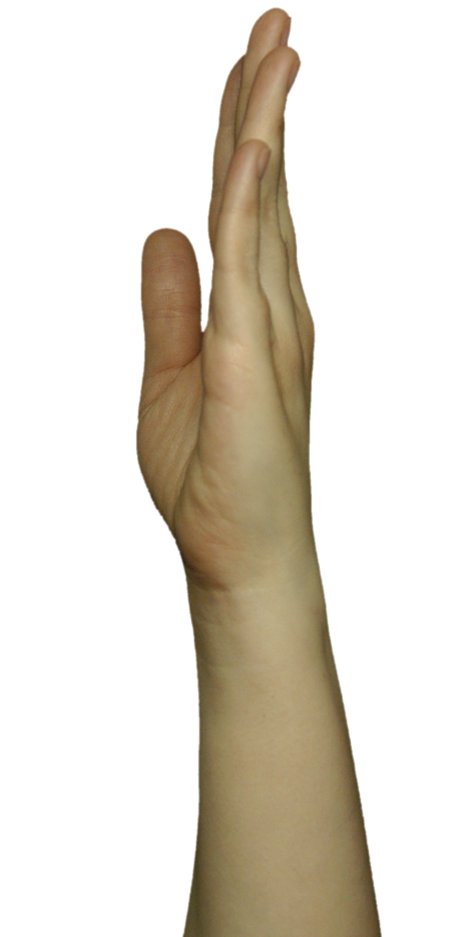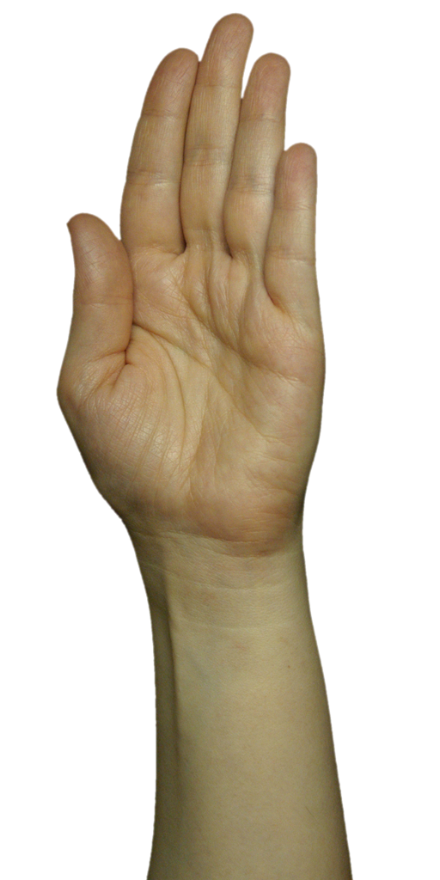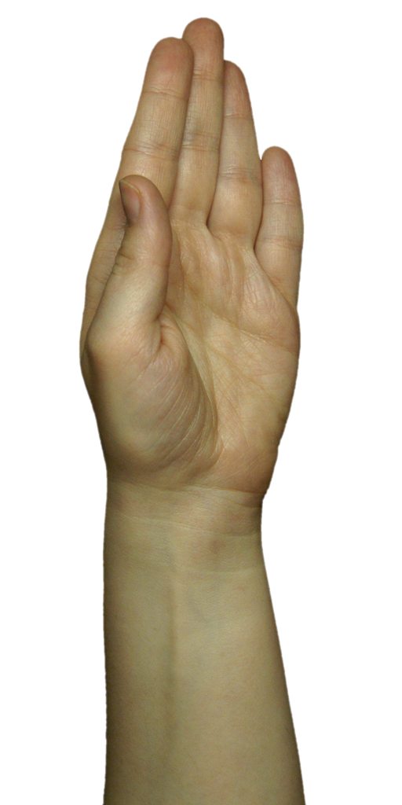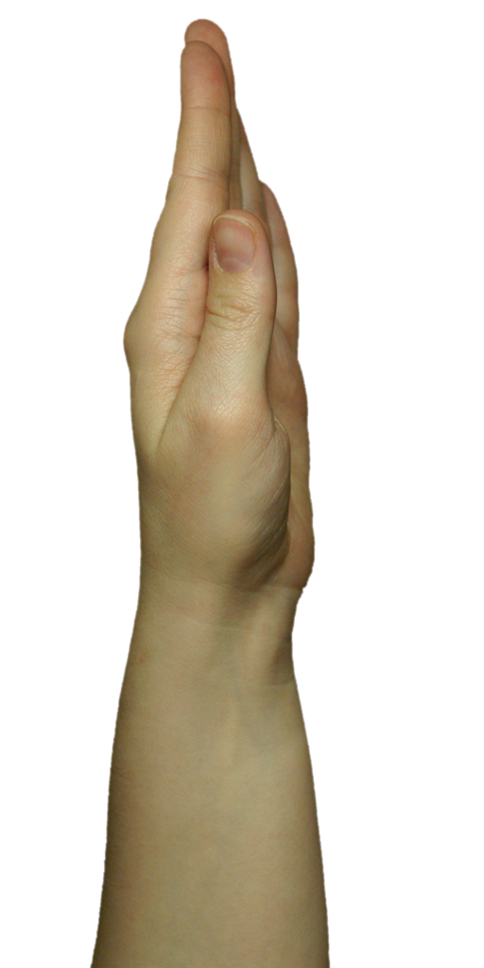

Glories of Accounting

Production

Exhibition History

Collections

Catalog and wall credits
"Surface Tension" 1991-2004. Plasma or retro-projection display, computer vision system. Variable dimensions.
Concept and direction: Rafael Lozano-Hemmer
Programming: Conroy Badger
Model: Bruce Ramsay
Production assistance: Will Bauer, Susie Ramsay, Tara DeSimone.

Selected Reviews

General Information

“Glories of Accounting” is an interactive display of human hands that follow people in an exhibition room. The piece consists of three elements:

1) One or multiple displays where the hands will be shown. This could be plasma screens or rear-projection systems with the following requirements:

a) Plasma

Size: 50” Diagonal image size (42” minimum)
Native Pixel Resolution: 1366 x 768 or higher (1024 x 768 minimum)
Aspect ratio: 16:9
Input: DVI preferred (VGA minimum)
Appearance: Black narrow border, no branding
Speakers: None
Mount: Wall mountable, vertically centred at 60” from floor
Horizontal Viewing Angle: 140 degrees or greater
Vertical Viewing Angle: 120 degrees or greater

The plasma screens receive images from the computer through a DVI cable. The pixel resolution of these images can be 1072 x 768 (XGA) up to 1920x1080 (HD).

The primary consideration when purchasing a plasma screen for this application is the width of the viewing angle, particularly the consistency in luminosity and contrast throughout the entire range of the viewing angle. The screen will be viewed from extreme and constantly varying angles. As the viewer walks from one side to the other the image intensity and contrast must remain consistent. Its appearance should be as non-descript as possible, preferably black with a thin border. There should be no major brand markings and the screen must be wall mountable.

An example of a suitable plasma is NEC's PlasmaSync 50XM4

b) Rear-Projection

Projected Image Size: 2 x 1.125 m to 4 x 2.25 m.
Projector Type DLP preferred
Contrast Ratio: 1500:1 or greater
Lumens: Depends on the ambient lighting, the size of the image, and the screen material, etc
Native Projector resolution: 1366 x 768 or higher
Panel Native Aspect ratio: 16:9
Input: DVI preferred
Suggested Screen: Stewart Film Screen 100 with snap frame
www.stewartfilmscreen.com
(800) 762-4999 (North America)
+45-36-48-2204 (Europe)
+65 67470555 (Asia)
Gain: 1.0 or greater
Viewing Angle: 86 deg. or greater (Half Gain)
Screen Placement: Place the screen and projector so that the hands align with the neck of a typical member of the public.

When using rear-projection, the collector should embed the screen so that it makes sense architecturally. If the exhibition has natural light, a plasma screen is recommended.

2) Surveillance Camera.

We provide the installation with a small 640 x 480 pixel firewire camera with a wide-angle lens. We use it at 15 fps, but a faster camera can also be used. Any firewire camera that can provide this resolution over firewire will work with the piece. The camera needs to be hung on the ceiling, in the centre of the room, pointed straight down.
Frame Rate: 15fps or greater
Resolution: 640 x 480 or greater
Interface: Firewire
Latency: .5sec or less

Any camera or interface that can deliver uncompressed video over firewire is acceptable, i.e. AVT, Unibrain, ADS, or an analogue camera connected via an Imaging Source DFG/1394-1 analogue to firewire converter. In addition the camera and its drivers should allow for image adjustment and be able to switch all of these adjustments to either automatic or manual.

3) Computer.

We provide a computer running Windows 2000 or XP, with at least 1GB of RAM, a Pentium IV or Core Duo processor and a firewire port. Any similarly equipped PC should work.

Processor Clock Speed: 2.0Ghz Single-core or 1.66Ghz Dual-Core min.
RAM: 512MB
Operating System: Windows 2000 or XP Service Pack2
Video Interface: DVI (VGA Minimum)
Video Input Interface: 6pin Firewire

Set-up and calibration

Installation placement:

The piece should be placed somewhere where people are naturally walking past the display because we want to maximize the amount of hand movement from side to side. For example, the piece should not be placed at the end of a corridor, as people will always approach the screen straight on. It is best to place the display in a wide room that ideally has a natural flow past the screen. For example; a room that has an entrance on one side and an exit on the other is a good candidate. The computer and camera should be hidden from view.

Camera setup:

The piece works by tracking participants in 2D in a specified tracking area. Ideally the tracking area will be the entire exhibition room, but sometimes, if the exhibition room is very large, the interactive area will just be an area that is close to the display.

The camera should be placed on the ceiling as much as possible in the centre of the interactive area, which is not necessarily the centre of the display. The location isn't critical, as long as there is sufficient height (Z) to maximize the camera's viewing area.

No metric calibration or measurement is required and therefore neither the camera nor the participant's 3D location is needed for tracking. All that the system needs is the angle from the participant to the centre of the hand on the screen. To make this simple, the camera is assumed to be overhead looking straight down at the participants. So it is essential that the camera lens be pointed straight down, —if the camera is tilted at an angle the hand’s rotation won't be accurate.

The camera should be rigidly attached to something that doesn't sway or vibrate. The ideal solution is to attach a threaded mount to the ceiling or a support beam and attach the camera to that. Point the camera with the lens straight down with the camera body parallel to the display, and the top of the camera towards the screen.

Below is a picture of a couple of good mounts with a ball swivel joint that makes camera adjustment easy:

The one on the left is great since you can easily bolt it to anything. The one on the right is also good but it is a bit more difficult to mount since a bolt must come down into the swivel joint. This is actually just a $10 tripod with the legs removed.

Lens Selection:

Once you have the camera in place, you need to decide on a lens. The lens must have a wide enough field of view to see the entire tracking area (down to peoples' knees) with a little bit to spare. The reason for the extra is due to the fact that the image needs to be corrected for radial distortion, which results in a loss of image at the edges. The type of lens the camera uses will make straight lines appear curved. Wider lenses produce more of a curve than narrow lenses, however, the curvature will be corrected so the program's math works.

Pick a lens that gives you more than enough coverage. After the lens is calibrated, you can check the image again to be sure it is still enough after the correction.

Lens Calibration:

The goal of the lens calibration is to remove the effects of radial distortion that occurs in any traditional lens assembly. The math for the program is based on the “pinhole” lens model. This model assumes a perspective mapping between the world and the camera CCD surface. Straight lines in the real world must map to straight lines in the camera image.

Please note: if you have already sent us CAD floor plans and elevations of the exhibition room we can pre-calibrate the lens. If your lens has already been calibrated you can skip all of the next sections until "Handtrack Software Setup"

Here's an example of radial distortion:

Notice the lines in the chessboard image as well as the edges of the paper are curved. In real life, these lines are really straight. Here's the same image after the effects of radial distortion are removed.

Notice the lines are now straight, just like in the real world. We can now use the camera to accurately measure angles to the hands. Also notice the edges of the image are gone. The image has been effectively stretched from the edges, and the extreme edges are lost. This is why you need to pick a lens that appears to initially give you more coverage than you actually need. To remove the effects of radial distortion, there's a program on the CD called “Calibrate”.

This program can do an internal (lens) calibration as well as an external (pose) calibration. ”Surface Tension” doesn't need to know the pose (position and orientation) of the camera, so you don't need to worry about that half of the program.

Here's a screenshot of Calibrate's main screen:

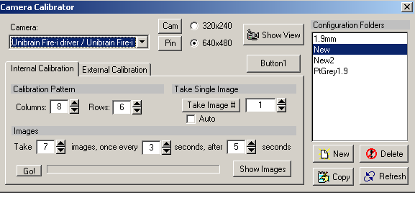
The list of configurations is on the right. You can create a new default configuration or create a copy of the current configuration. In addition, you can rename a configuration by typing directly in the configuration list on the right. Currently there's no way to delete a configuration from the software. You can easily do so from windows by selecting the configuration folder from an explorer window and pressing delete. Note that the program remembers the last configuration loaded, and if it notices the folder missing it will recreate it for you and add a default configuration. Switch to another configuration before deleting any old configurations, or the old one will be recreated by the program when it launches again.

You'll want to start with a new configuration, so click “New”. Select your camera from the drop-down menu on the left. Select the “320x240” resolution since this is what ”Surface Tension” uses. If you press the “Show View” button, you'll be able to see the current camera view.

To perform the calibration, you'll need to have a calibration pattern mounted on a firm flat backing, such as a clipboard. You can print the pattern out right from the program. We have always used the 8x6 pattern.

Once you have your pattern printed out and mounted, press the “Show View” button to see the camera view. Adjust the camera settings so you get a clean, well exposed, image. Press the “Cam” button to bring up the adjustment screen, shown below.

This is the adjustment screen for an ADS pyro web camera under XP. Both tabs are shown. Other cameras may have more or less controls or tabs.

Here are some tips on adjusting the image.

If the exhibition room will have steady, controlled, artificial illumination, then all camera settings should be set to manual (e.g. exposure, brightness, white balance check boxes should not be checked). In such a situation, we want a steady, non-changing image.

If the exhibition room has any natural light, i.e. if the light will change dramatically in the exhibition room according to the time of day or varying weather conditions, then set exposure and brightness to auto in order to ensure that the camera can see people during any lighting conditions.

2) Go for maximum exposure without clipping and maximum contrast. If the image is too washed out, turn down the brightness. Only then if the image is still too bright, bring down the contrast. Try to leave the exposure at maximum if you have control over it.

3) Surface Tension does not use colour. If you are using a colour camera, turn the saturation all the way down. Although the image is automatically converted to grey scale after the radial distortion, you should take the colour out now. That way, the image that you see, and are adjusting to is the same image (minus the radial distortion) that the tracking algorithm will see.

4) The sharpness setting is critical for the internal calibration. If the lines are too sharp, there will be artefacts that will throw off the calibration routines. If the lines are too blurry, the computer won't be able to find the corners of the chessboard image.

For example, the image on the left is a bit blurry, the one in the middle is just right And the one on the right has artefacts from over-sharpening.

Once you have your camera adjusted close the adjustment screen.

Taking Calibration Images

You can choose the number of images you want to use for the calibration. You'll need at least 3. Using more images will give you a better calibration. We recommend the default 7 images.

You can take the pictures one at a time or in sequence. Pressing the "Go" button near the bottom will start the computer taking pictures automatically in sequence, with a beep after each picture is taken.

You can also take a single picture by selecting the image # to take and pressing the "Take image #" button. This is handy if the computer failed to find the chess board corners in some of the images but not all. It's also nice because it gives you instant feedback on whether the image was good or not. If the image passed, the program's title bar will say "Ok". If another image needs to be taken, it will say "Bad".

Start with the automatic method, and replace the failed images one at a time with the single shot option. After you've taken your images, press the "Show Images" button, taking you to the internal calibration screen, shown below.

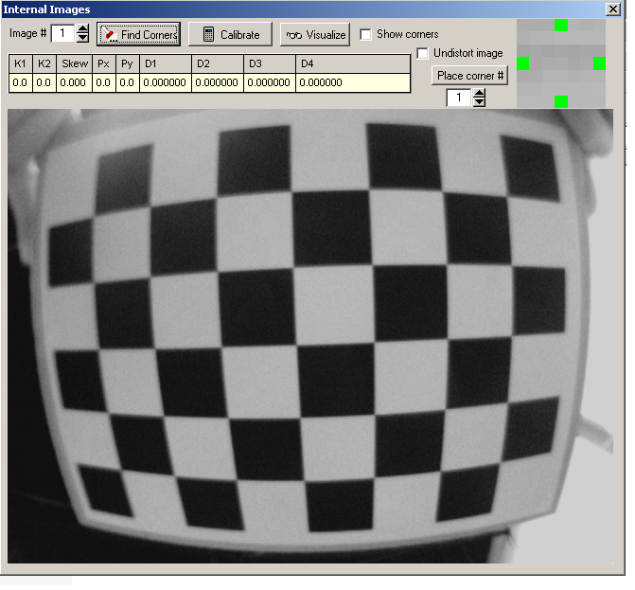

You can select the image to view from the image # edit. Press "Find corners" to have the computer find the corners for you. This will usually result in about half the images failing and half passing.

If 4 of the images pass, for example, and 3 fail, simply go back to the previous screen and take single shots of the failed images. Select the image # in the edit and press the "Take image #" button until the caption says ok.

Once you have a set of images that the PC is happy with, you can verify the corners by checking off the "View corners" check box. The corners should be numbered sequentially and place at the intersections of the chessboard squares.

To perform the actual internal calibration, press the "Calibrate" button. The table will fill with values regarding the lens’ distortion. To test the calibration, check the "Undistort image" check box. Check all the images with the "Image #" edit to make sure all the lines in the images appear reasonably straight.

You can now check the camera view to see what kind of coverage you're going to have after the lens distortion correction. Go back to the main screen

By selecting live feed and undistort from this screen you will see the live feed of the camera corrected for radial distortion. Hopefully your camera can still see enough of the tracking area. If not, you can only go back and pick a wider-angle lens.

Exit this program and you're ready for the next step. Please note that this lens calibration is only needed once per lens and camera, if you move the installation to a different exhibition room you will not need to redo this calibration if you are using the same lens and camera.

Handtrack software setup:

The main program is called "Handtrack" and it should be set to start-up automatically when the PC is powered on. At start-up, the program pre-loads all the hand bitmaps. There are 70 of them and these are texturemapped using openGL. Make sure the PC has at least a gigabyte of ram. Any less and the program will slow down as it swaps bitmaps in and out of memory to disk.

The files will take a few minutes to load. Once loaded the project starts automatically.

If you left click with the mouse while the project is running a window will allow you to go to the set-up screen, to view tiffs or to Track (i.e. start the project agan). You can close this window to quit the program.

If you right click with the mouse while the project is running a pop-up menu will let you select "setup" and "view tracking" which will show a floating window that shows the camera tracking (this can be placed in a secondary window if this is wanted). CTRL right click will open a pop-up menu in which you can select "mouse test", which will let you simulate targets to ensure that the system is working well.

1) Screen setup (right click)

Selecting this item will take you to the tracking setup screen.

This screen lets you configure the tracking area and other parameters related to tracking.

Here's a screenshot: IMAGE

Camera Settings

Flip/Mirror:
Select Flip and or Mirror to orientate the camera so that the plasma screen is at the top of the video image.

Load Cal Data:
First, you need to tell this program about the lens calibration that was performed previously. To do this, press the "Load Cal Data" button and navigate to the calibration folder used to perform the internal calibration of the lens previously. Once you do this the lines in the camera image should be straight again.

Settings:
Usually good results are achieved when selecting Debayering, B/W Debayering and Gamma.
It is important to account for changing light situations over the course of a day and also not to pickup too much visual noise.
Gain Auto
White Balance U 795
White Balance V 455
Brightness 0
Exposure 3300
The higher the exposure the lower the frame rate will be. Assure that the frame stays at 15 frames per second. The fps are displayed at the left bottom corner of the video image.

Origin pixels

Place:
You also need to specify the origin pixels of the display. You need to put one origin pixel (blue) at the very left side of the LCD, at about tracking (chest) height and the other (red) on the very right side of the LCD at tracking height. The clicking the left and right mouse button places these pixels. Note that the display should always appear at the top side of the camera's view. To adjust or change this, move the orientation of the camera or select flip and/or mirror in the main setup window.
This way the system knows the pixel coordinates of the edges of the screen.

Tracking Parameters

Defining the tracking area:
To define the tracking area, click on "set track area". In the window that appears you can left click to draw areas where you do want tracking and right click on areas that you want masked. Mask to exclude regions of the exhibition room that might have moving objects that you do not want the hand to focus on. For example, if the field of view of the camera can see a revolving door, a fluttering curtain, a turnstile, electric escalators, or a kinetic sculpture then the hand will constantly be looking at this movement.

Here's a screenshot: IMAGE

Threshold:
You can adjust the tracking thresholds here. When the system is tracking, it looks for blobs of bright pixels that have changed since the previous frame. At first it's more discerning in the threshold at which it considers a pixel to be "on". This is the high threshold. Once an "on" pixel has been found, it's more tolerant with its idea of an "on" pixel, and uses the low threshold.
The tracking uses previous frame subtraction, meaning the computer subtracts the previous camera frame from the current. This makes the system immune to changing lighting conditions. So a low of 15 and a high of 25 usually work fine.

Jump Distance:
This is the distance in pixels the system will look to find an "on" pixel before giving up. This value isn't extremely critical either and usually can be set between 10 - 12.

Minimum area:
This defines the minimum area a blob has to occupy before it is considered a target, before a hand appears and turns towards the blob's/person's position.
Depending on the height and zoom of the camera this will need to be adjusted to account for the area a person takes up in real space.
If the system is tracking something as small as a hand, you'll want to increase this. If people are being lost when only 1/2 their body is outlined you'll want to decrease it so the system is more forgiving.

Merge distance:
Merge distance is the distance in pixels vertically between 2 blobs for them to be able to merge into 1. The point at which 2 blobs are considered part of the same blob. This was previously hard coded to 10. It might help to increase it if the targets are breaking up too much.
Increasing the number will decrease the number of blobs but the downside is people will be merged together if they're standing too close together.

Max lost time:
Even though the system can't see stationary targets, it still does what it can to track a single person around the room. The "Max lost time" edit specifies the time in seconds a person can stop for and still be tracked. Once a person stops moving, and becomes lost, the system starts counting for max lost time seconds. If the person starts moving again (or another person within MaxPixelsPerFrame of the previously lost target), within this time, the system stops counting and continues tracking. If not, the target will be truly lost and another target can now be picked up by the system.

Usually people stop moving for only a few seconds at a time so a value or 2 seconds for "Max lost time" is usually sufficient for exhibits where there will be a lot of traffic. A value of zero is the default and it is suitable for more private exhibits with less public.

Averages:
To "smooth" the tracking, we average the tracked position over a number of frames. For smoother tracking, increase this number. For faster tracking decrease it. The default value of 4 is usually a good compromise between speed and smoothness.

Maximum pixels/frame:
The "maximum pixels per frame" is the maximum distance in pixels the target can move in a single camera frame. This value may have to be tweaked depending on the speed of the participants and the height of the camera, but the default value 150 is usually pretty close. If the system loses people who are moving too fast then this value will have to be increased. If the tracking is jumping from person to person too often, this value should be decreased.

Minimum age:
White targets are all potential targets. Basically the instantaneous raw output of the blob finder. Then the system matches up new targets with old ones by proximity - these are the tracked targets since they're followed frame to frame. The system won't give any hands to a target until it reaches a minimum age. This is to prevent spurious break ups - sometimes one target might break into two for a few frames if the lighting is right - this just makes sure the target is real. So the young tracked targets which don't control anything but are still being tracked are grey. When they turn yellow it means they're old enough and they are controlling hands.
Increasing min age will make the system less jittery but the hands will be delayed and it will take them longer to show up on the screen.

low 10
high 40
jump 12
min area 150
merge 0
lost time 4.0
averages 2
max pix/frame 200
min age 10

Hand Parameters:

Max hands:
This defines the maximum number of hands possible that can appear on the screen. A single screen (41 inch) should not have more than 4 hands assigned to it.

Max linger:
If a single target is controlling several hands, this will tell the system how many seconds to use to randomly remove the hands….i.e. if you set this number to zero all hands will disappear at the same time and if you set it to 4 seconds the hands will take anywhere between 0 and 4 seconds to disappear.

Also if a target is truly lost the corresponding hand will also disappear with in the time set at max linger.

Min Spacing:
This is the minimum distance in pixels that will exist between the centre of two hands. This is to avoid a hand appearing exactly over another.

Hand-Edge:
This is the distance between a hand's edge and the very left and very right edge of the entire collection of screens. Don't let a hand only appear half on the screen.
Hand-Gap:
If using multiple screens, this defines the spacing between the edge of a hand the the middle of the gap in between two screens.
Hand-Hand:
This is the distance in pixel between he edges of two hands. Select a negative number for the hands to slightly overlap. The hands should not overlap more than 1/3.

On a 103 cm wide screen the following values work fine: Hand-egde 50, Hand-gap 50, Hand-hand -2.

Display Parameters

Width/height radio:
This number changes the size of the hands. The hands are females hands

Gap between displays:
This is the distance starting from the last visible pixel on one screen to the first on the next screen.

2) View tracking

This screen simply lets you watch the tracking in real time for debugging. Here's a screenshot:

You can select what the system shows in the foreground as well as show the tracking border.

That's about it. Test the tracking, making sure there are no dead spots, which are sometimes caused by bright overhead lights. If there are problems adjust the lighting conditions or the tracking polygon to exclude the problem areas. The tracking should be fairly quick and fluid and the hand should twitch naturally to appear animated.

3) Mouse Test
Close the setup screen.
CRTL right click will popup a menu in which you can select mouse test.
While in mouse test the video tracking is disabled and the tracking can be simulated in this window. There are 8 ellipse each with a different colored rim. When click on a ellipse it becomes solid and will become an active target. A hand will appear on the main screen. The hand will follow the position of the ellipse once you move it around.

Redo
Clicking on Redo will generate a new set of hands, one for each solid ellipse.
To do this multiple times is a good way to check if the distance between the hand and to the edge are as desired.

4) View tiffs

By moving the slider at the top, you can select the frame index of the bitmap to see. In total there are 70 frames.

You can also change the "angle" of each of the frame images. There is a set of defaults that Rafael is happy with but if you ever need to change them this is where you do it. Simply view the hand image and mark a spot on the floor where you think it's pointing. Perhaps the easiest way to do this is to place a tape measure in parallel with and in from of the LCD screen. Then you can go through each of the forty frames in turn and mark where on the tape the hand appears to be pointing. Note that when we calibrated these originally with Rafael, he faked it a bit so that more of the hand images are used. For example, even though the first image is set for -79 degrees, the hand isn't actually pointed there - it's actually much less, maybe -65 degrees. But by artificially spreading the images out you can achieve a much more linear change in the hand frames, and the extreme angle hand images are used more often.

Here's how to measure the angles from the hand.

For frame #5 above, the distance from the zero degree measurement to where the hand path crosses the tape measure is measured. It will be a negative number since the hand is to the right and is shown as X5 in the image above. To find the angle, take the arc tan of X5/Y. For example, if X5 =2 and Y =1, the angle would be ArcTan(2/1) or -63 degrees.

5) Exit.

This exits the program. To dismiss the popup press the "esc" key on the PC keyboard.

Test the tracking, making sure there are no dead spots, which are sometimes caused by bright overhead lights. If there are problems adjust the lighting conditions or the tracking area to exclude the problem areas. The tracking should be fairly quick and fluid and the hands should turn naturally to appear animated.

Adjust the Plasma Screen:
Sometimes the default color setting of the screen makes the hands look a bit sick. Increase amount of red color to counter this.

Replication and troubleshooting:

The piece runs using software developed by engineer Conroy Badger from APR Inc. in Edmonton, Canada. He can be contacted at conroy.badger@shaw.ca or at Tel 1-780-450-8261. The software is custom-programmed in Delphi using Open computer vision libraries from Intel and it runs on Windows 2000 or XP. The source code is available to the collector so that in the future the project can be recompiled for a different operating system.

The software will automatically use any and all available resolution available from the connected projector or plasma and graphics card. When future resolutions are available this project will automatically generate higher resolution images, up to 1600x900 pixels. After that, higher resolutions can be used but this will not improve the crispness of the eye. You are welcome to resample the source images to get higher resolution through interpolation.

When in the future a superior computer vision tracking technology is developed this can be used for the piece. In particular it would be great to be able to better discriminate when a detected presence is made of one big person or a couple hugging. Also, improvements in latency and precision would be welcome.

If the camera fails you can purchase another one, so long as it has a firewire interface, it can shoot at 320x240 or 640x480 pixel resolution at 15 fps or more with a low latency. The cameras we supply are purchased from unibrain.com and they are colour board cameras Part no. 21-BCANOL-OEM / US 2056 fitted in a plastic housing for Fire-I board camera. Typically, we fit the camera with a 12mm-thread wide-angle micro lens, such as the 107-degree lens from unibrain, Part no. 20-BRDLEN-190/US 4382. See appendix I for specs.

Other cameras that may be used are Pyro by ADS and iBot by OrangeMicro, though both of those models have been discontinued. Another solution is to use any analogue camera hooked-up to the DFG/1394-1 FireWire frame grabber from Imaging Source (www.1394imaging.com). Other frame grabbers such as models from ADS or Miglia will not work because they cannot supply the required resolution of 320x240 pixels.

The PC ships with VNC software installed so that you may place remotely control the PC for debugging or troubleshooting. This can be done using the existing WIFI or Ethernet network interface.

We provide a PC running Windows 2000 or XP, with at least 1 GB of RAM, a Pentium IV processor and a firewire port. Alternatively, we provide a 1.66Ghz Core Duo Intel Mac mini running Windows XP SP2 under Boot Camp. Any similarly equipped PC should work, but ideally there should be a video card with a DVI output and 128MB VRAM. If a display has a large native resolution the software will generate new images to match the new resolution. This means that any display above 1366 x 768 pixels might need to use a PC with more than 1 GB of RAM so that all the images can be preloaded into RAM and the performance of the piece is not slowed down by loading images from the hard drive. See Appendix II for computer specs.

